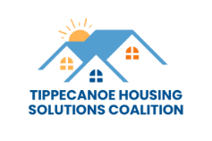

Housing Stability Taskforce Agenda
July 23, 2025

- Introductions

- What is the Tippecanoe Housing Solutions Coalition

- Overview and Purpose of the Housing Stability Taskforce

- Members and who is missing

- Goal

- Needs and Impact

- Strategies

- Potential Solutions

- Next meeting date

